**PURCHASE AND SALE AGREEMENT**

**BY AND BETWEEN**

**BUYER 1**

Represented by: **BUYER REP**

**AND**

**CHANGZHOU KYA TRADING CO LTD - JIANGSU, CHINA**

Represented by: **TURBO WOLF GENERALTRADING LLC - DUBAI, U.A.E**

THIS PURCHASE AND SALE AGREEMENT is entered into this 10TH day of January 2018, by and between **BUYER 1** represented by **BUYER REP** (hereinafter referred as "Buyer") with office address at the United Arab Emirates and **CHANGZHOU KYA TRADING CO LTD - JIANGSU, CHINA** represented by **TURBO WOLF GENERALTRADING LLC - DUBAI, U.A.E** (hereinafter referred as "Seller”) with office address at Dubai, United Arab Emirates.

**RECITALS:**

**WHEREAS,** the **CHANGZHOU KYA TRADING CO LTD - JIANGSU, CHINA** represented by **TURBO WOLF GENERALTRADING LLC - DUBAI, U.A.E and BUYER 1 represented BUYER REP** can enter into this Sale and Purchase Agreement and sign pertinent documents with full rights under terms and conditions specified therein;

**WHEREAS,** the **CHANGZHOU KYA TRADING CO LTD - JIANGSU, CHINA** desires to sell the Products defined below and the **BUYER 1** desires to purchase the Products from **CHANGZHOU KYA TRADING CO LTD - JIANGSU, CHINA.**

**NOW THEREFORE**, in consideration of the mutual covenants and the agreements herein contained and other goods and valuable (the receipt and sufficiency of which are hereby acknowledged) the parties agree as follows:

1. **Sale of Product**. **CHANGZHOU KYA TRADING CO LTD - JIANGSU, CHINA** hereby sells to **BUYER 1** and **BUYER 1** hereby purchases from **CHANGZHOU KYA TRADING CO LTD - JIANGSU, CHINA** the product details below:

|  |  |  |  |  |
| --- | --- | --- | --- | --- |
| **DESCRIPTION** | **QTY** | **UM** | **UNIT PRICE** | **AMOUNT** |
|  |  |  |  |  |
|  |  |  |  |  |
|  |  |  |  |  |
|  |  |  |  |  |

1. **Purchase Price**.  **BUYER 1** shall pay to **CHANGZHOU KYA TRADING CO LTD - JIANGSU, CHINA** for the Products and for all obligations specified herein, as full and complete consideration therefore, the sum of **EURO 2,000,000.00** (Two Million Euro only).
2. **Payment**. Payment of the Purchase Price shall be made by **BUYER 1** or its representative **BUYER REP** to **CHANGZHOU KYA TRADING CO LTD - JIANGSU, CHINA** or its representative **TURBO WOLF GENERALTRADING LLC - DUBAI, U.A.E** in full payment in advance before the delivery date.
3. **Acceptance**. “Acceptance" of the Product shall be deemed to occur on the date when, in the reasonable opinion of **BUYER 1** the Product conforms to the Specifications, and has continuously operated in compliance with the Specifications for thirty (30) days after Product Turnover
4. **Indemnification.** In the event either party breaches or is deemed to have breached any of the representations and warranties contained in this Agreement, or fails to perform or comply with any of the covenants and agreements set forth in this Agreement, it shall hold harmless, indemnify and defend the other party, and its directors, officers, shareholders, attorneys, representatives and agents, from and against any damages incurred by the non-defaulting party.
5. **General.** **CHANGZHOU KYA TRADING CO LTD - JIANGSU, CHINA** shall perform this Agreement in compliance with all applicable local laws, rules, regulations, and ordinances, and represents that it shall have obtained all licenses and permits required by law to engage in the activities necessary to perform its obligations under this Agreement.

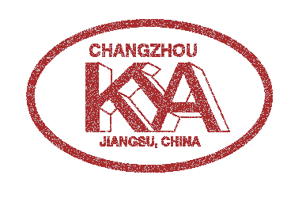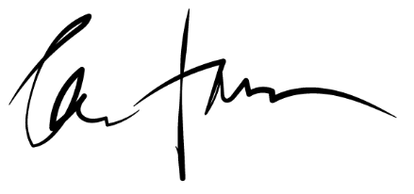

**_________________________________________________________________**

**CHANGZHOU KYA TRADING CO LTD - JIANGSU, CHINA**

**_____________________________________**

**BUYER 1**